# 1

# The Firefly Forest

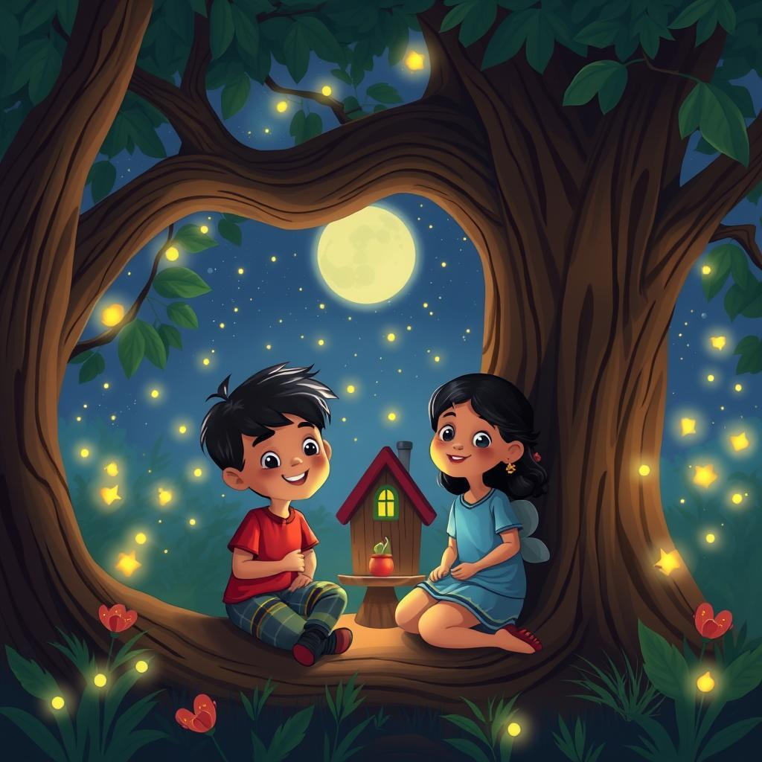

Ramy and Lamia loved to play in the Firefly Forest. It was a magical place, full of tall trees and twinkling lights. Every night, when the sun went to sleep, the fireflies woke up and filled the forest with their tiny, glowing lanterns. Ramy would run through the forest, his feet barely touching the ground, chasing the fireflies that danced like tiny stars. Lamia would giggle and clap her hands, her eyes shining with wonder.   
  
One night, they found a big, old tree with a hollow inside. It looked like a cozy little house. Ramy peeked inside and saw a tiny bed made of leaves, a table with a plate of berries, and a lamp made of a firefly jar. "Look, Lamia! It's a firefly house!" he shouted, his voice filled with excitement. Lamia jumped up and down, her eyes wide with amazement. She picked up a small, red berry and ate it, pretending she was a little firefly having dinner.   
  
They played in the firefly house for a long time, singing songs and telling stories. They pretended they were fireflies, flying through the forest, shining their lights and making new friends. They saw a family of owls sleeping in a tree, a sleepy bunny hiding under a bush, and a little mouse peeking out from its hole. The fireflies danced around them, their tiny lights illuminating the forest like magic.  
  
As the moon climbed high in the sky, it was time for Ramy and Lamia to go home. They said goodbye to the fireflies, promising to come back tomorrow night. They walked hand in hand, their hearts full of joy and their heads full of dreams. They knew that the Firefly Forest was a magical place, where anything was possible, and they couldn't wait to go back and explore it again.

# 2

# The Whale Watching



Ramy and Lamia were so excited! They were going whale watching with their mom and dad. They put on their life jackets and climbed onto the big boat. The boat was bumpy, and Lamia giggled as the waves splashed on her face. Ramy looked out at the ocean, hoping to see a whale.   
  
Suddenly, a loud splash! A huge black fin emerged from the water and then a whale's tail! "A whale! A whale!" Lamia shouted, jumping up and down. Ramy was so happy he clapped his hands. The whale swam around the boat, showing off its big, powerful body. Lamia pointed at it and said, "Look, Ramy! It's waving at us!"   
  
The whale stayed around for a long time, making the water spray and sending a thrill through everyone on the boat. Ramy and Lamia kept waving at the whale, their faces filled with wonder. They couldn’t believe how big and amazing it was.   
  
After the whale disappeared, Ramy and Lamia sat down next to their parents. They talked about the whale and drew pictures of it in their notebooks. Ramy knew he would never forget this day. He was so happy to have seen a real whale and to share it with his little sister Lamia. They both knew they would tell their friends all about the amazing whale watching adventure.

# 3

# The Moonlit Beach

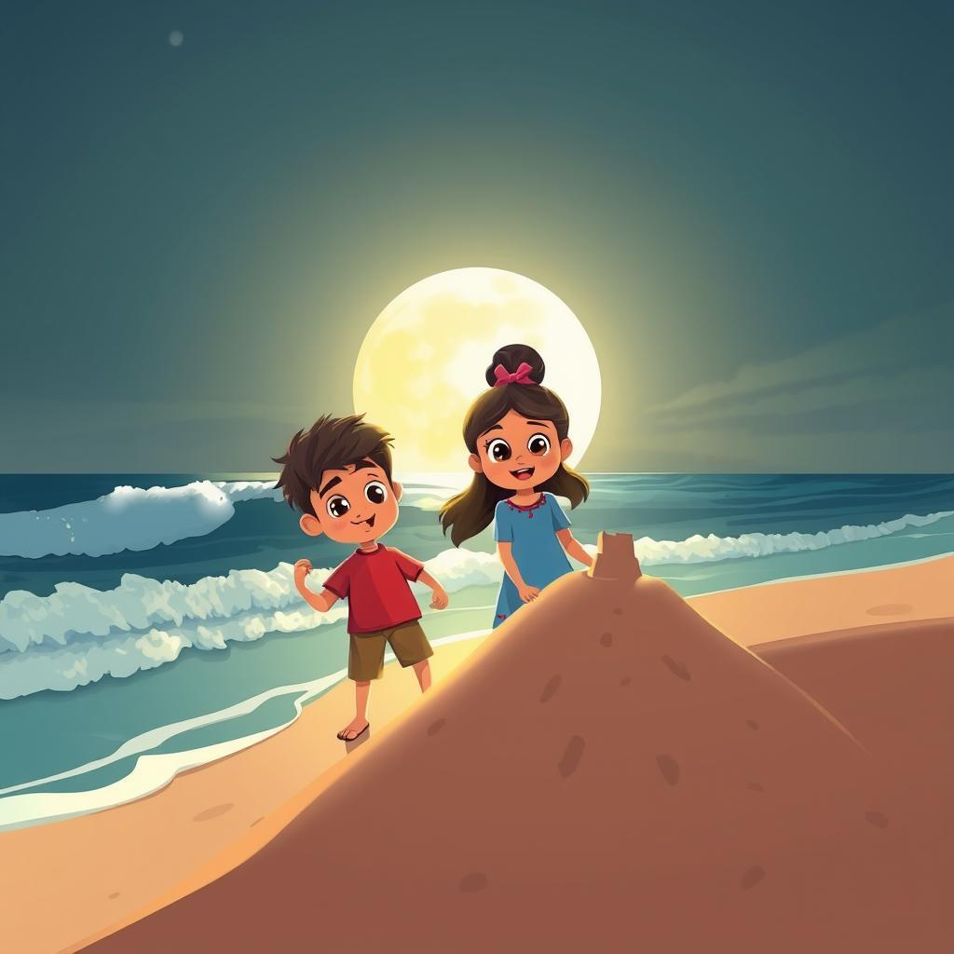

Ramy loved the beach. He loved the soft sand between his toes and the cool sea water splashing on his legs. But most of all, he loved the moonlit beach. The moon made the waves shimmer like silver, and the sand glowed like a million tiny stars. One night, Ramy went to the beach with his little sister, Lamia. Lamia was only four years old, and she loved to laugh and run.   
  
Ramy built a sandcastle for Lamia. He made tall towers and a wide moat around it. Lamia giggled as she watched him. When the castle was finished, she ran around it, making funny sounds and pretending to be a princess. Ramy laughed too, watching her happy face. Then, they built a big sand fort together. They worked hard, piling sand high and digging a deep trench around it. They built walls so strong, they thought no sea monster could ever break them.   
  
Suddenly, a big wave crashed against the sand fort. Ramy and Lamia gasped. They had forgotten about the tide! The water rushed in, breaking down their fort and washing away all their hard work. Lamia started to cry. But Ramy held her hand and smiled. “Don’t worry,” he said, “We can build another one. And this time, we'll build it even stronger!"   
  
Lamia wiped her tears and nodded. She loved building forts with her brother. They laughed and played until the moon was high in the sky. Then, they walked hand-in-hand back home, their hearts full of the magic of the moonlit beach. They knew that even if the waves washed away their sand fort, their love for each other would always be strong.

# 4

# The Ice Palace

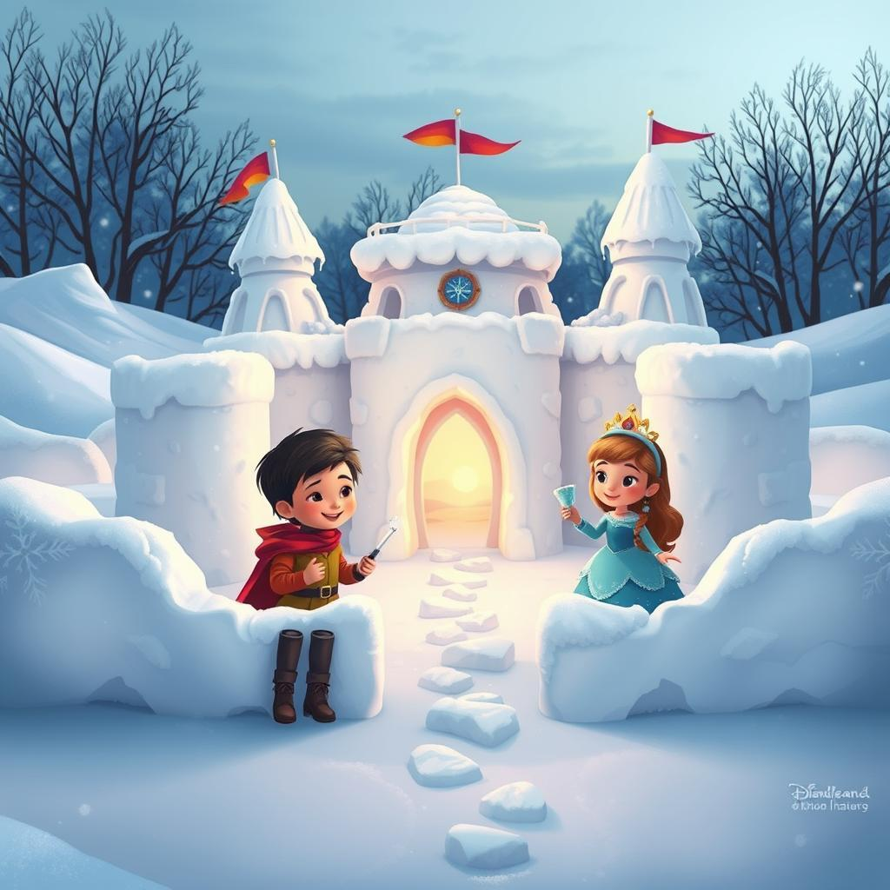

Ramy and Lamia were two happy children who loved to play. One cold winter day, they decided to build a big, sparkly palace out of snow. Ramy, the older brother, rolled big snowballs like bouncy balls. He stacked them high, making the walls of their palace. Lamia, the little sister, helped by piling up smaller snowballs, making the roof and towers. They laughed and giggled as they worked, their breath making puffs of white in the frosty air.  
  
When the palace was finished, it was the most beautiful thing they had ever seen. It sparkled in the sunshine, all white and shiny. Ramy and Lamia decorated it with colorful flags and sparkly stones they found in the garden. They even made a throne for their pretend king and queen out of a big block of ice.   
  
Ramy was the brave knight, protecting the palace from imaginary monsters. He used a wooden sword and a big shield made of cardboard. Lamia was the beautiful princess, wearing a sparkly crown and a fluffy dress. They pretended to have tea parties and sing songs about their adventures. They were so happy, lost in their world of make-believe.  
  
As the sun started to set, casting long shadows, it was time to go inside. Their palace would melt away in the warm night, but the memory of their fun would stay with them forever. They would dream of the Ice Palace and their adventures, waiting for the next snow day to build another magical kingdom.

# 5

# The Snowy Mountain



Ramy and Lamia were two little kids who loved playing in the snow. One day, their family went on a trip to the Snowy Mountain. The snow was so white and fluffy, like giant marshmallows covering the ground! Ramy was excited to build a snowman, so he rolled up big snowballs, one bigger than the other. Lamia, being smaller, built a tiny snowman with her hands. She giggled as the cold snow tickled her fingers.  
  
Then, they decided to play hide-and-seek. Ramy, being the older brother, hid behind a big pine tree. Lamia, with her little legs, ran behind a snowdrift. Ramy peeked out, looking for his sister. He saw her tiny brown boots sticking out from the snow. "I found you, Lamia!" he shouted, and Lamia jumped out, laughing with glee.  
  
The sun began to set, turning the snow a beautiful pink color. The kids built a snow fort, with a tunnel leading inside. They played inside, pretending to be brave knights and princesses. Lamia even made a tiny snow castle for her dolls. As the evening grew colder, their parents called them back to the warm cabin.  
  
Ramy and Lamia snuggled up next to the fireplace, their cheeks rosy from the cold. They were tired but happy, their hearts full of memories of their snowy adventure. They knew that even though the mountain was far away, they would always remember their fun day playing in the snow.

# 6

# The Fantasy Forest

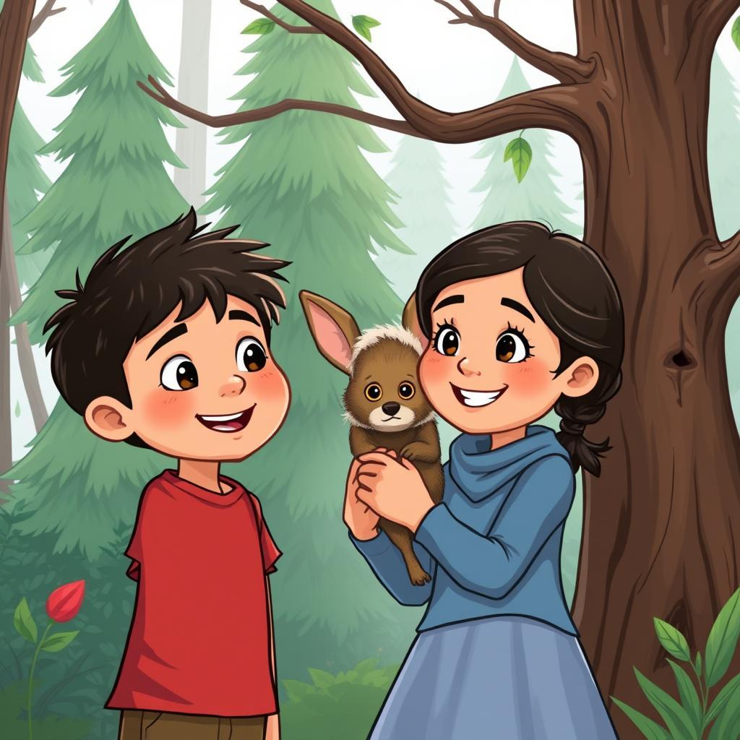

Ramy and Lamia loved to play in the Fantasy Forest. It was a magical place, filled with tall trees that whispered secrets in the wind and funny little creatures that peeked out from behind the leaves. Ramy, who was older, was always the brave one. He would swing from branches like a monkey, his laughter echoing through the trees. Lamia, his little sister, was always a little scared, but she loved to follow Ramy and watch him play. One sunny day, Ramy and Lamia decided to climb the tallest tree in the forest. They climbed and climbed, their hands and feet finding little handholds in the rough bark. Finally, they reached the top, and the whole forest looked like a green carpet below them.   
  
Suddenly, Lamia saw something strange. A little creature with big ears and fluffy fur was hiding behind a branch. It looked scared, and its big eyes filled with tears. "Ramy," Lamia whispered, pointing to the creature. Ramy looked, too, and saw the little creature shivering. He was scared of the creature at first, but then he saw how sad it looked. "Don't worry," he said to the creature in a gentle voice. "We won't hurt you." The creature looked at Ramy and then at Lamia. It seemed to understand. It slowly crawled closer and snuggled into Lamia's lap.   
  
Ramy and Lamia spent the rest of the afternoon with the little creature. They shared their lunch with it and told it stories about the magical forest. The creature seemed to like their stories and laughed along with them. When the sun began to set, it was time to go home. Ramy and Lamia said goodbye to their new furry friend and promised to visit it again soon. They climbed down the tree, feeling happy and a little bit brave. They knew that even though they were small, they could be brave and kind, just like their hero, Ramy.  
  
As they walked home, hand-in-hand, they couldn't stop talking about their new friend. They decided to name it Fuzzy, because of its fluffy fur. Lamia, who was no longer scared, even promised to bring Fuzzy some special berries from their garden the next time they visited the Fantasy Forest. That night, they dreamt of tall trees, whispering leaves, and Fuzzy, the little creature with big ears and a warm heart. They knew that the Fantasy Forest held many more secrets, and they were ready to explore them, together.

# 7

# The Iceberg

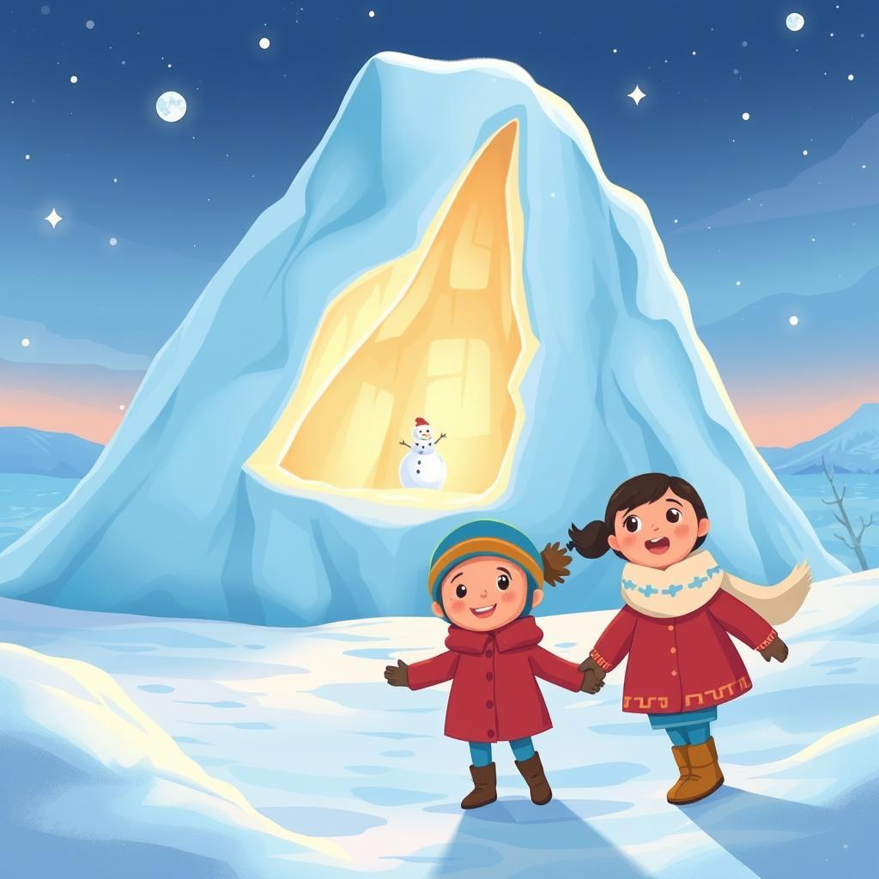

Ramy was a brave boy. He loved to play outside, even when it was cold. One day, a big, white iceberg floated near his house. It was so big, it looked like a giant mountain of snow! Ramy wanted to climb it, so he put on his warm coat and boots and called for his little sister, Lamia.   
  
Lamia was a bit scared of the iceberg. It was so cold and big! But Ramy promised to hold her hand and keep her safe. He helped her climb up the icy slope, and they laughed as they slipped and slid. The sun sparkled on the ice, making everything shimmer and shine. They found a small cave in the iceberg, and they crawled inside to hide. It was dark and cold, but cozy.  
  
Ramy and Lamia played in the cave for a long time. They made snowballs and threw them at each other. They sang silly songs and told each other stories. They even built a little snowman with ice and pebbles. They were having so much fun!   
  
Then, it started to get dark. The sun disappeared, and the shadows grew longer. Ramy and Lamia knew it was time to go home. They crawled out of the cave and climbed down the icy slope. They held hands tightly as they walked back home, their cheeks rosy from the cold and their hearts full of joy. They had had a wonderful adventure on the big, white iceberg!

# 8

# The Mystery Island

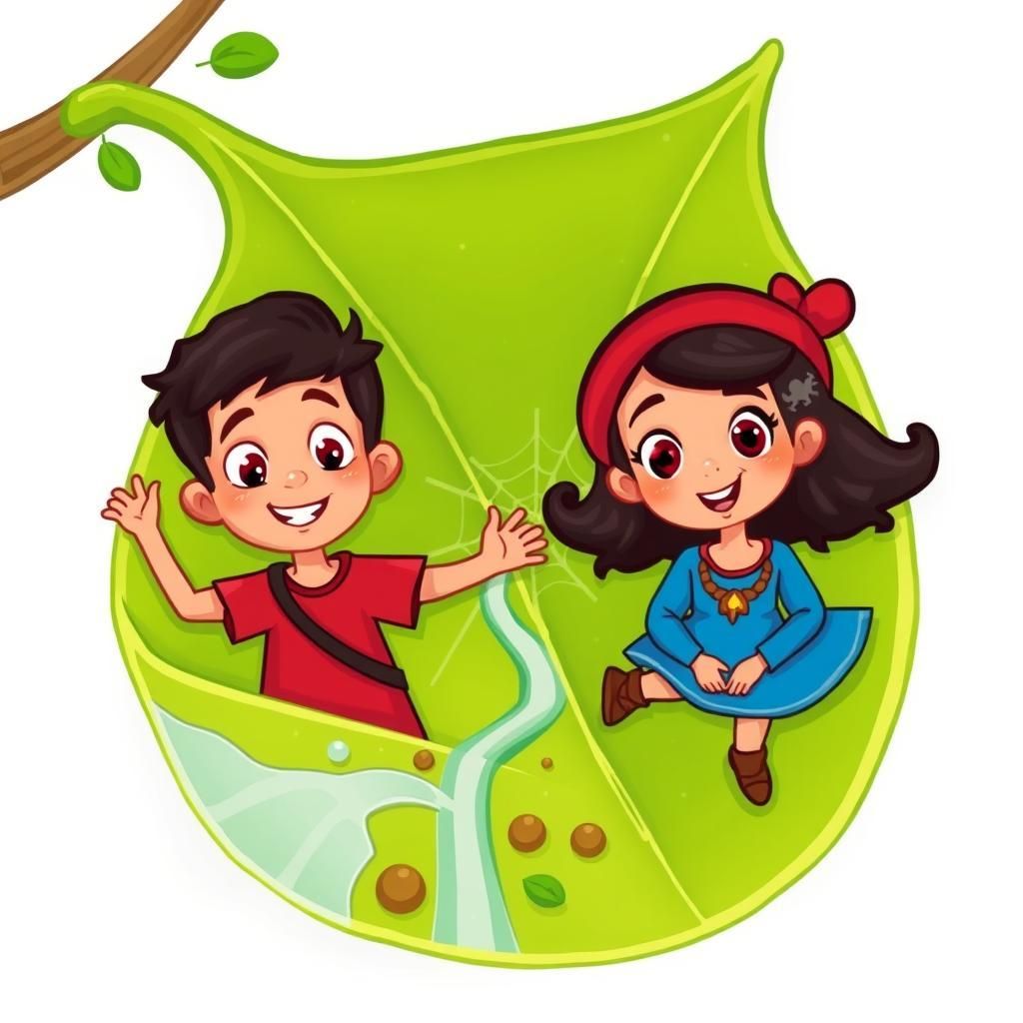

Ramy, a boy with hair as dark as night and eyes as bright as the sun, loved to explore. His little sister, Lamia, with her tiny pigtails and a smile that could melt ice, loved to follow him everywhere. One day, they found a big, green leaf in the garden. It was so big, it looked like a little island! "Let's call it Mystery Island!" Ramy shouted, his eyes sparkling with excitement. Lamia giggled and nodded, her little hands clutching her favorite stuffed bunny.  
  
They climbed onto the leaf, feeling like pirates on a ship. Ramy, the captain, held a stick like a telescope and pretended to see faraway lands. "Look, Lamia!" he cried, pointing. "There's a giant waterfall!" He pointed to a small stream trickling near the leaf. Lamia gasped and giggled, pointing to a tiny ladybug that crawled across the leaf. "It's a monster!" she squealed, but her eyes were full of laughter.   
  
Ramy pretended to fight off the monster with his stick, making whooshing sounds. Lamia cheered, her bunny clutched tight in her hands. They climbed a small hill on the leaf, pretending to be mountain climbers. They saw a spiderweb shimmering in the sunlight. "Look, Lamia, a giant spiderweb!" Ramy whispered, his voice full of wonder. Lamia, wide-eyed, pointed to a little spider spinning a new thread. "It's weaving magic!" she whispered, her voice barely a breath.  
  
As the sun began to set, casting long shadows across the garden, Ramy and Lamia knew it was time to go home. They walked back to the house, their faces lit with the memory of their adventures on Mystery Island. They knew, in their hearts, that the island wasn't just a big leaf, but a place where anything was possible. It was a place where they could be explorers, pirates, mountain climbers, and anything they could imagine. And they knew that they would return to Mystery Island again, ready for more adventures.

# 9

# The Rainforest Canopy

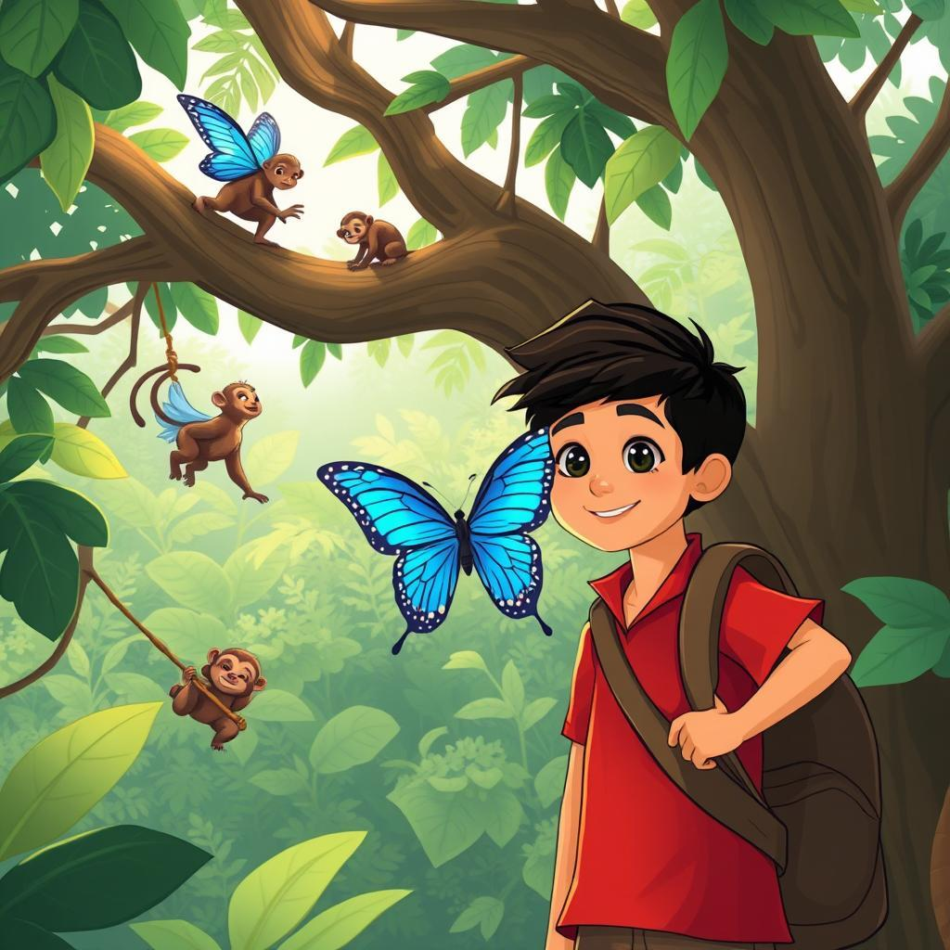

Ramy, a boy with eyes like the bright sun, loved to explore the rainforest. He was brave and always knew where to find the best hidden paths. Today, he was leading his little sister, Lamia, with her hair like a waterfall of dark curls, on an adventure high up in the canopy. They climbed a giant fig tree, its roots like strong arms reaching into the earth. Up they went, climbing on gnarled branches and using vines like ropes to pull themselves higher. The rainforest floor was a green blur below them, and the air was filled with the songs of birds and the rustle of leaves.  
  
Reaching a high platform of branches, Ramy looked around with a grin. "Look, Lamia!" he whispered. "We're like birds, high above the world!" Lamia giggled, her eyes wide with wonder. She pointed at a family of monkeys swinging through the trees, their brown fur catching the sunlight. Then, a beautiful blue Morpho butterfly landed on Ramy's shoulder. Its wings shimmered with colors like a rainbow. Ramy held his breath, afraid to move, and Lamia gasped in awe. The butterfly stayed for a moment, then flew away, leaving behind a trail of blue light.  
  
Ramy and Lamia spent the afternoon playing in the canopy. They pretended to be explorers, searching for hidden treasures in the leaves. They swung from branches, giggling with joy. They even found a small, shy sloth hanging upside down from a branch. Lamia, always gentle, offered the sloth a sweet, ripe mango she had brought with her. The sloth took the fruit slowly, munching on it with a quiet, satisfied smile.   
  
As the sun began to set, painting the sky with fiery orange and purple hues, Ramy and Lamia knew it was time to go home. They climbed down the fig tree, their hearts full of the magic of the rainforest. Ramy held Lamia's hand tightly, and they walked back home, whispering secrets about their adventures, their faces glowing with the memory of their journey through the canopy. The rainforest had whispered its secrets to them, and they would cherish them forever.

# 10

# The Sunken Ship

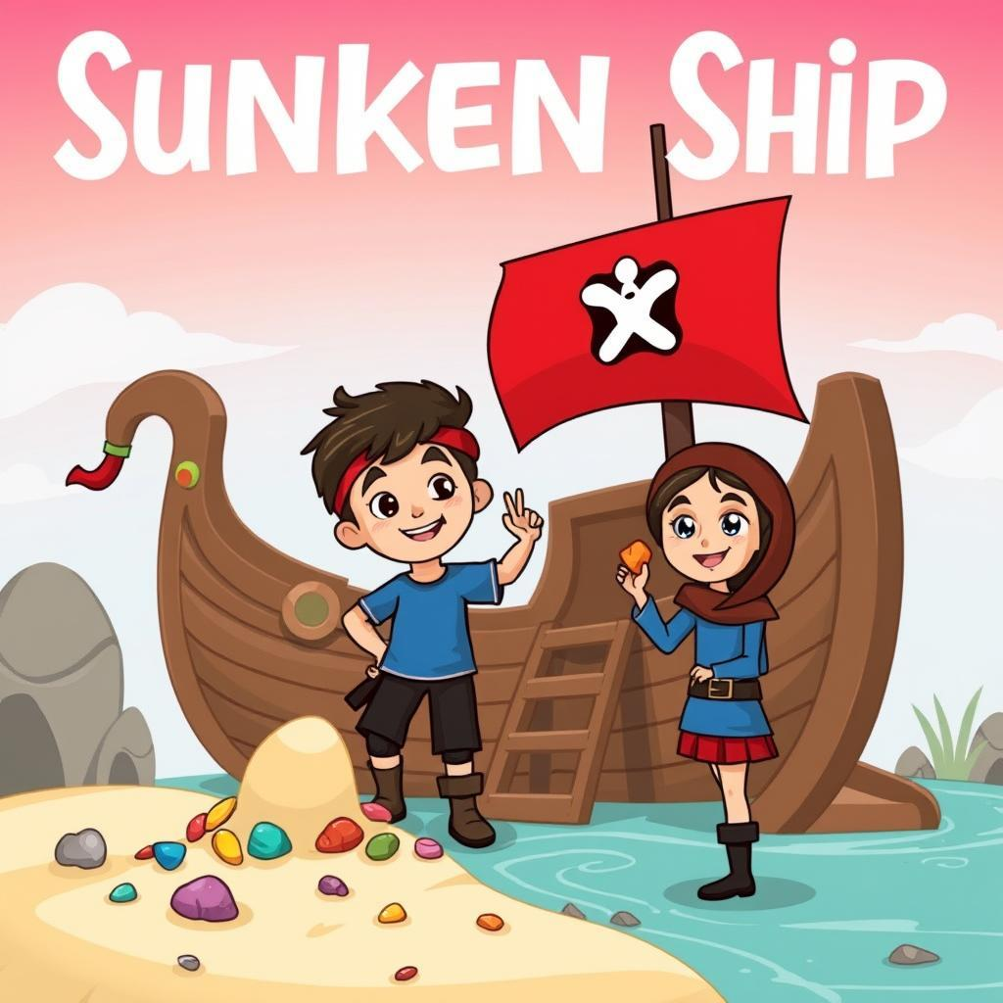

Ramy and Lamia loved to play at the Sunken Ship. It was a big, old playground with a slide that looked like the side of a ship. It had a wooden wheel and a rope ladder to climb up. Ramy was a brave boy, he loved to climb the ladder and slide down fast. Lamia was a little girl, she liked to play in the sandbox and make castles.   
  
One sunny day, Ramy and Lamia went to the Sunken Ship. Ramy climbed the ladder, giggling with excitement. He reached the top and looked down. He saw Lamia building a sandcastle near the slide. "Look, Lamia!" he shouted, "I'm at the top of the ship!" Lamia looked up and waved. "Come down, Ramy!" she said, "Let's play pirates!" Ramy slid down the slide and landed with a thump. He laughed and ran to Lamia.   
  
"We need a treasure chest!" he said. They looked around and found a big box near the sandbox. They opened it and found lots of colorful rocks and shells. "Wow!" cried Lamia, "This is the perfect treasure!" Ramy picked up a shiny rock and gave it to Lamia. "Here, this is your pirate treasure," he said. They put all the rocks and shells into the box and closed it. Now, they had a real pirate treasure chest.  
  
Ramy and Lamia played pirates all afternoon. They pretended to sail on the slide, climbed the rope ladder to look for sea monsters, and hid their treasure in the sandbox. The Sunken Ship was their favorite place to play, full of adventures and fun. They loved to play pretend and use their imaginations, turning rocks into treasure and the playground into a real pirate ship.

# 11

# The Glowing Grotto

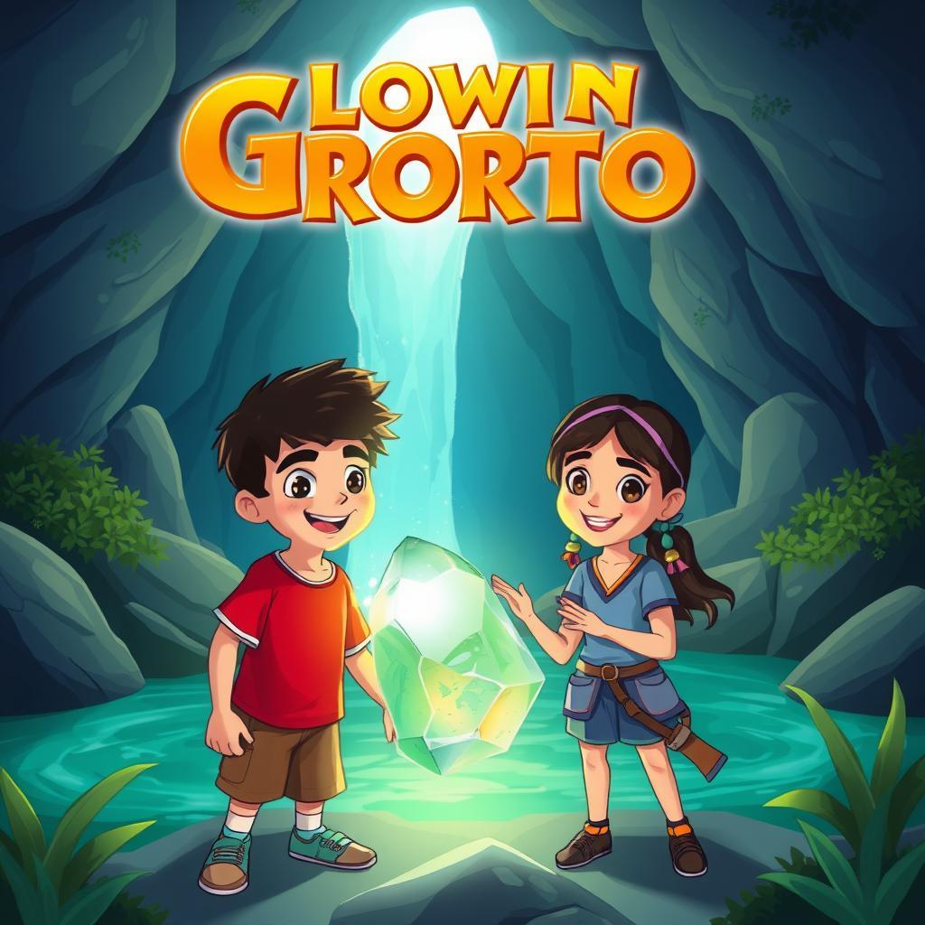

Ramy and Lamia loved to play in the Glowing Grotto. It was a special place, hidden behind a waterfall in the woods. Sunlight trickled through the leaves above, making the water sparkle like diamonds. Tiny lights glowed on the walls of the cave, like fireflies trapped in stone. Ramy, the older brother, would pretend to be a brave explorer, searching for hidden treasure. Lamia, his little sister, would follow close behind, giggling and clapping her hands.  
  
One day, they found something new in the Grotto. A big, shiny rock, covered in swirls of blue and green. It looked like a giant marble, but it was warm to the touch. Ramy picked it up carefully, and it glowed even brighter than the other lights in the cave. Lamia gasped, "It's magic!" Ramy held the rock up to the sunlight, watching it shimmer and change color. Suddenly, a tiny voice whispered from the rock, "Welcome, adventurers. I am the Guardian of the Grotto."  
  
Ramy and Lamia jumped back, surprised. "Who are you?" asked Ramy, his voice shaky. The Guardian chuckled. "I am the spirit of this cave, and I watch over its secrets." Lamia peeked behind Ramy, her eyes wide with wonder. The Guardian continued, "You have found something special, children. This rock holds the power of the Glowing Grotto. Use it wisely, and it will bring you good fortune."   
  
Ramy and Lamia couldn't believe their ears. They had met a magical guardian and received a special gift. They promised to take care of the glowing rock and keep the secrets of the Grotto safe. They knew their adventures were just beginning. From then on, the Glowing Grotto became even more magical, filled with the laughter of two children and the secret whispers of a friendly guardian.

# 12

# The Tropical Rainforest

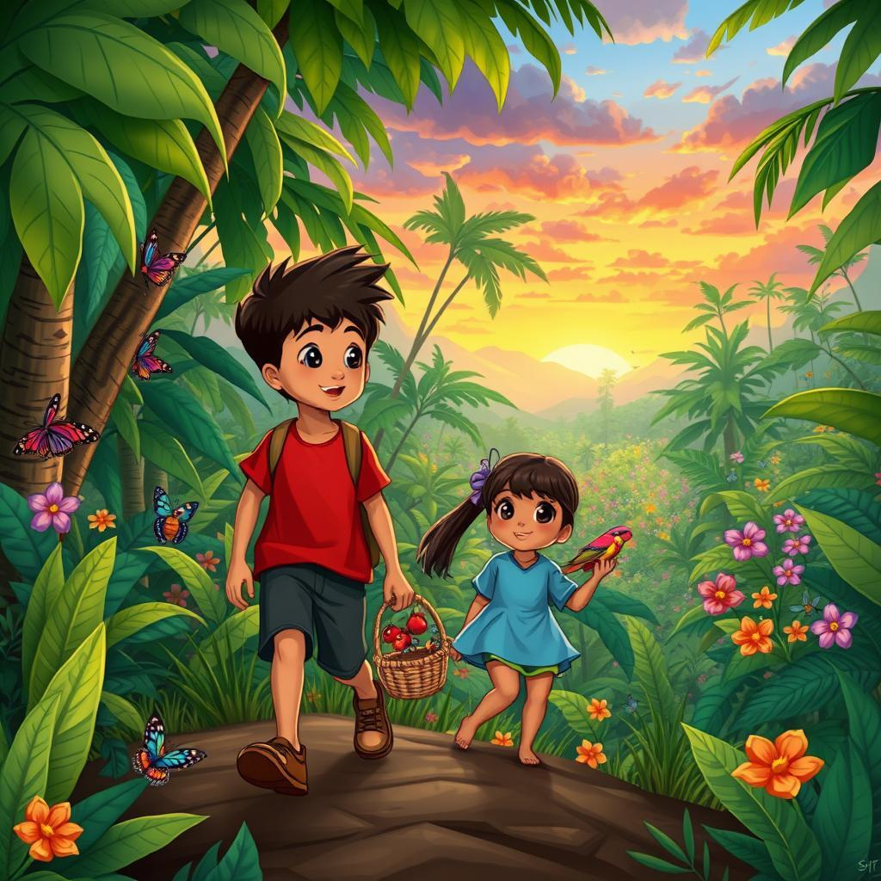

Ramy and Lamia were two kids who lived in a big green jungle. It was a tropical rainforest, filled with tall trees and bright flowers. The air was warm and damp, and the leaves rustled in the gentle breeze. Ramy was older, and he loved to explore. He would swing on vines and climb trees, searching for hidden treasures. Lamia, his little sister, loved to follow him and watch him play. She would giggle and clap her hands at all the exciting things she saw.  
  
One day, they decided to go on a grand adventure. They took their baskets and filled them with delicious mangoes and juicy pineapples they found on the forest floor. They then set off on a path through the jungle, following the sounds of chirping birds and chattering monkeys. They saw huge butterflies with wings like painted rainbows, and colorful snakes slithering through the undergrowth. Ramy pointed out funny-looking bugs with long legs and Lamia laughed at their wobbly walk.  
  
Suddenly, they came to a clearing. It was filled with beautiful flowers of all colors. Some were red and orange, some were yellow and purple, and some were even blue and green. Lamia gasped and ran towards them, picking them carefully. She wanted to take them home to make a special flower crown. Ramy helped her pick the best ones. He knew that their mother would love the colorful flowers.  
  
As they walked back home, the sun began to set, turning the sky into a fiery orange and pink. They were tired but happy, their baskets filled with treasures from the jungle. They hugged each other and thanked the rainforest for the wonderful day. They knew they would be back again soon to explore more of its secrets.

# 13

# The Frozen Tundra

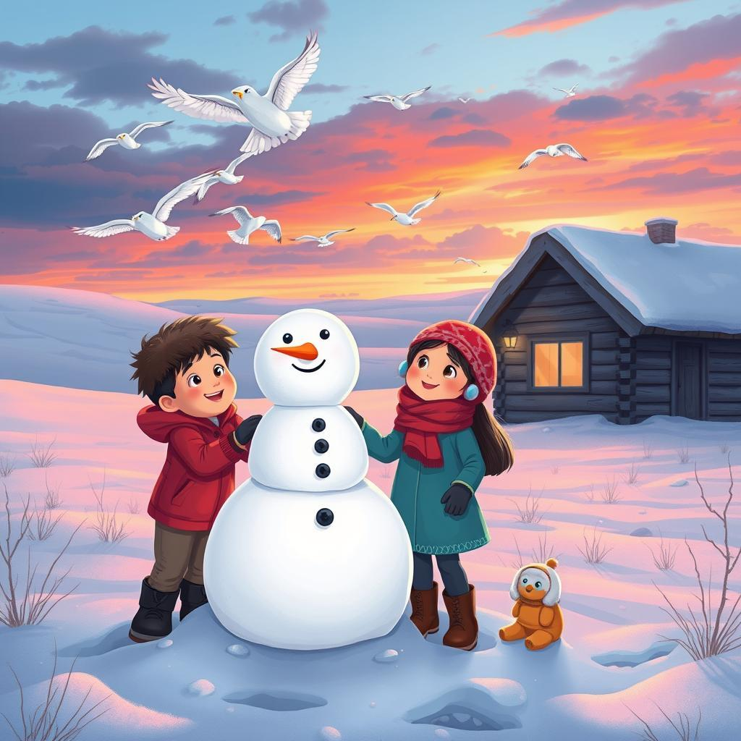

Ramy and Lamia were playing in the Frozen Tundra. The snow was white and fluffy, like a giant blanket covering the land. Ramy, the older brother, was building a snowman. He rolled big snowballs, one on top of the other, until he had a tall, funny snowman. Lamia, the little sister, giggled as she helped him put twigs for arms and pebbles for eyes. The snowman looked so silly, with a carrot nose and a crooked smile.  
  
Suddenly, a gust of wind blew across the tundra. It was so strong, it almost knocked over Ramy's snowman. Lamia hugged her brother tightly, her eyes wide with surprise. "Look!" she cried, pointing at the sky. A flock of snowy owls flew overhead, their white feathers blending with the clouds. They swooped and circled, their silent wings cutting through the air. Ramy and Lamia watched in awe, mesmerized by the graceful birds.   
  
The sun began to set, painting the sky in shades of orange and pink. The air grew colder, and the snow started to sparkle. Ramy and Lamia knew it was time to go home. They packed up their snowman's accessories, promising to build him again tomorrow. Hand in hand, they walked back to their warm cabin, their hearts filled with the magic of the Frozen Tundra.  
  
As they stepped inside, their mother greeted them with a warm smile and a mug of hot chocolate. Ramy and Lamia snuggled up by the fireplace, sharing stories of their adventure. The snowy owls, the playful wind, and the giant snowman - all part of their wonderful day in the Frozen Tundra. They knew that even though the winter was long and cold, there was always beauty and wonder to be found in the frozen land.

# 14

# The Meteor Shower

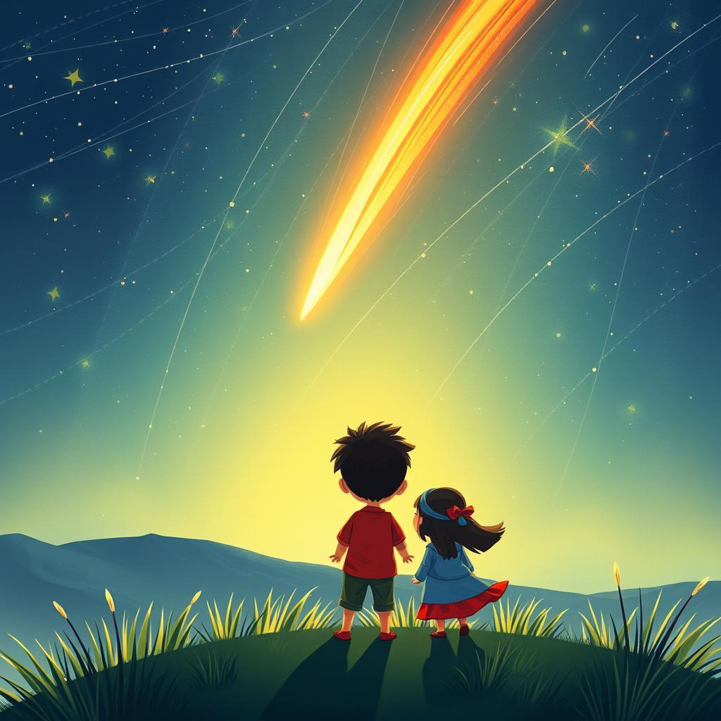

Ramy, a boy with bright eyes and a mischievous grin, grabbed his little sister Lamia's hand. "Come on, Lamia! Let's go see the shooting stars!" he exclaimed. It was a night like no other, with the sky filled with twinkling stars and a magical shower of shooting stars falling like glittering rain. Lamia, with her pigtails bouncing, skipped beside him, her eyes wide with wonder. They ran to the hilltop, the cool night air whispering through their hair.  
  
The hilltop was their secret spot, a place where they could watch the stars and imagine magical stories. They sat down on a soft patch of grass, their eyes glued to the sky. The shooting stars flew across the darkness, leaving shimmering trails behind them. Ramy pointed to the brightest ones, shouting, "Look! There goes a dragon! And there's a unicorn!" Lamia giggled, her laughter echoing in the quiet night. She closed her eyes and made a wish on each falling star, hoping for a pony and a rainbow-colored ice cream.  
  
Suddenly, a bright, fiery meteor streaked across the sky, leaving a long, smoky trail. It was the biggest and brightest meteor they had ever seen. "Wow!" cried Ramy, his eyes wide with awe. Lamia clapped her hands, her face beaming. They held each other tight, feeling a little scared but mostly filled with excitement. The meteor seemed to be falling closer and closer, and they watched with bated breath.   
  
As the meteor disappeared behind a distant mountain, Ramy whispered, "I wish we could fly up there, Lamia, and touch the stars." Lamia nodded, her eyes sparkling. They sat in silence for a while, watching the remaining meteors streak across the sky. Even though they couldn't touch the stars, they knew they had seen something magical and beautiful. It was a night they would never forget, a night filled with wonder and dreams under the shimmering sky.

# 15

# The Dragon's Nest

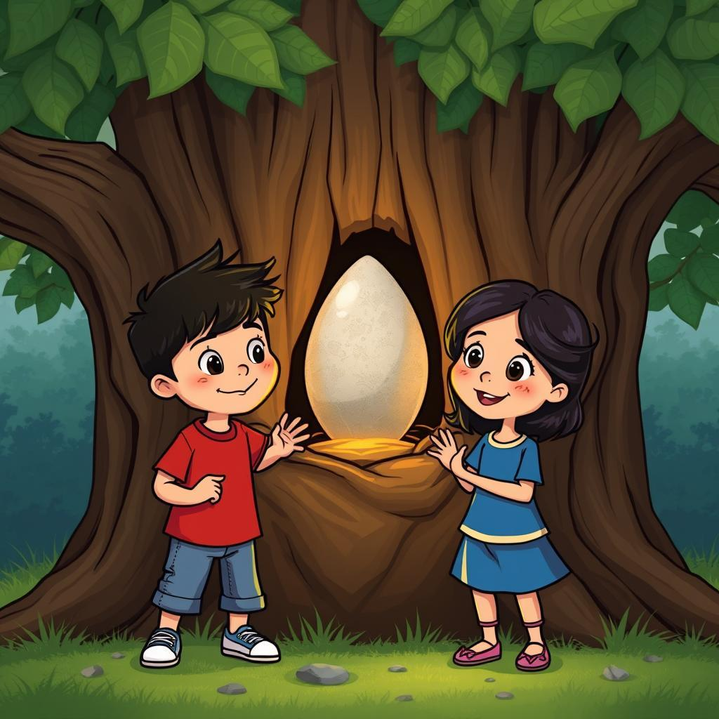

Ramy and Lamia loved to play in the Dragon's Nest. It wasn't a real nest, of course. It was just a big, old oak tree in their backyard, with branches that twisted and turned like a dragon's claws. Ramy, being the bigger brother, always climbed the highest, pretending to be a brave knight. He would shout, "I'm going to slay the dragon!" and Lamia, his little sister, would giggle and hide behind the trunk, pretending to be a princess.   
  
One sunny afternoon, they were playing in the Dragon's Nest again. Ramy was climbing to the top, his brown hair bouncing with every step. Lamia was below, making a crown of daisies for herself. Suddenly, Ramy cried out, "Look, Lamia! A treasure!" He held up a small, shiny stone, sparkling in the sunlight. "It must be a dragon's egg!" he exclaimed. Lamia gasped and ran over. "Maybe we can hatch it!" she said, her eyes wide with excitement.   
  
Ramy and Lamia took the "egg" back home, carefully wrapped in a leaf. They decided to keep it secret from their parents, just in case it was a real dragon egg! They made a cozy bed for the egg in Lamia's toy box, whispering stories about dragons to it. They waited patiently, day after day, hoping for a tiny dragon to peek out. But nothing happened. The egg stayed smooth and shiny.  
  
One day, their mother found the "egg" in Lamia's toy box. "What's this?" she asked. "It's a dragon's egg!" Lamia shouted, bouncing with joy. Her mother smiled, "It's just a pretty stone, my dear. But it's very special because it reminds you and your brother of your adventures in the Dragon's Nest." From then on, the stone became a reminder of their imaginary dragon, their secret, and their fun-filled days in the Dragon's Nest. Even though it wasn't a real dragon egg, it was a treasure just as good.

# 16

# The Polar Ice Cap

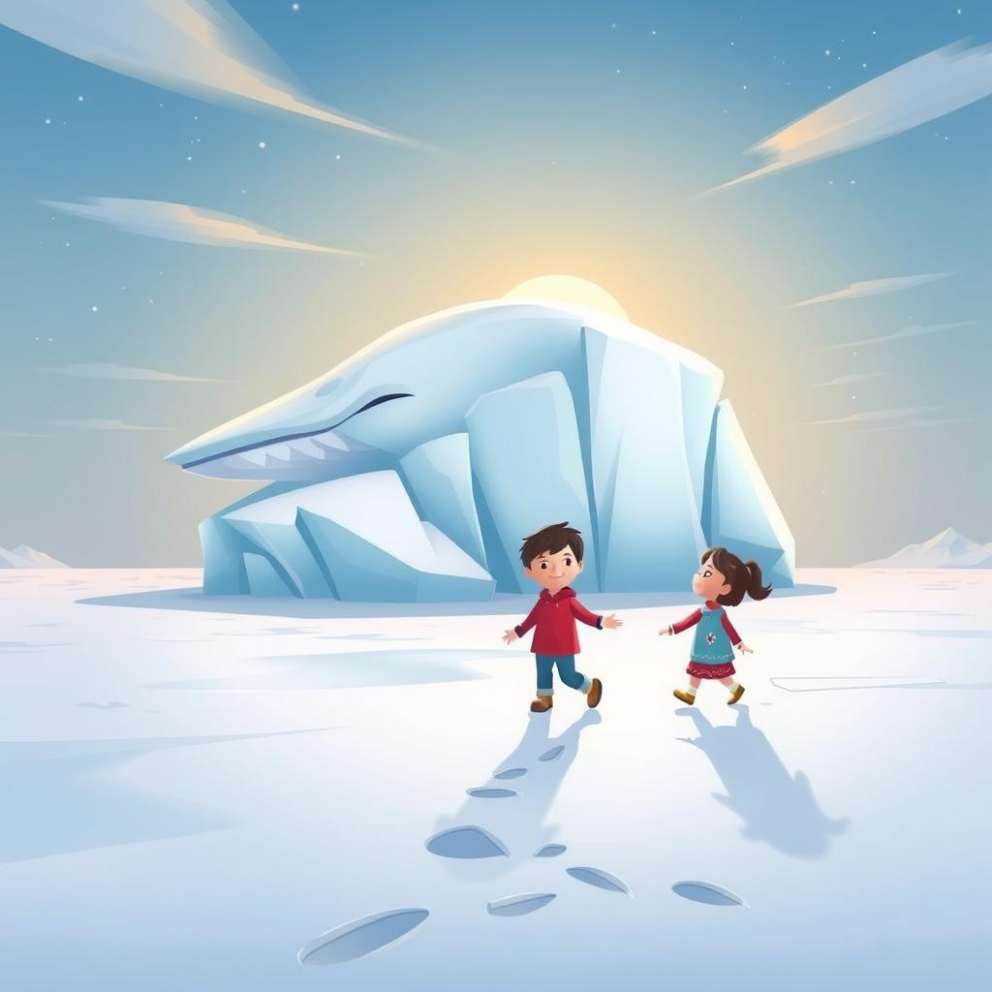

Ramy, a brave boy with a bright red hat, stood at the edge of the vast, white Polar Ice Cap. The sun, a pale, yellow circle in the sky, shone weakly on the frozen world. Beside him stood his little sister, Lamia, her tiny hands buried deep in her puffy winter coat. "Look, Lamia!" Ramy shouted, pointing towards a giant iceberg that looked like a sleeping whale. "Let's climb it!"   
  
Lamia, her brown eyes wide with wonder, nodded eagerly. Together, they clambered over the icy, uneven surface, their boots crunching on the frozen snow. The air was cold, but Ramy and Lamia were too busy exploring to notice. They found a small cave inside the iceberg and pretended it was a magical home for ice fairies. Lamia even found a tiny white feather, which she declared was from a magical ice bird.  
  
As the day wore on, the sun began to set, painting the sky with hues of pink and orange. The air grew colder, and the wind started to howl. Ramy and Lamia knew it was time to go home. They retraced their steps, giggling as they made snow angels on the soft snow. They packed their things and walked back hand-in-hand, their little footprints the only sign of their adventure on the pristine white ice.  
  
Back at their cozy cabin, Ramy and Lamia huddled by the fire, their faces glowing with warmth. They sipped hot chocolate and told their parents about their amazing adventure on the Polar Ice Cap. Ramy described the giant iceberg and the magical ice fairies, while Lamia recounted the story of the ice bird and her precious feather. Their parents listened with smiles, knowing that the memories of their adventure would stay with them long after the last snowflake melted.

# 17

# The Ancient Ruins

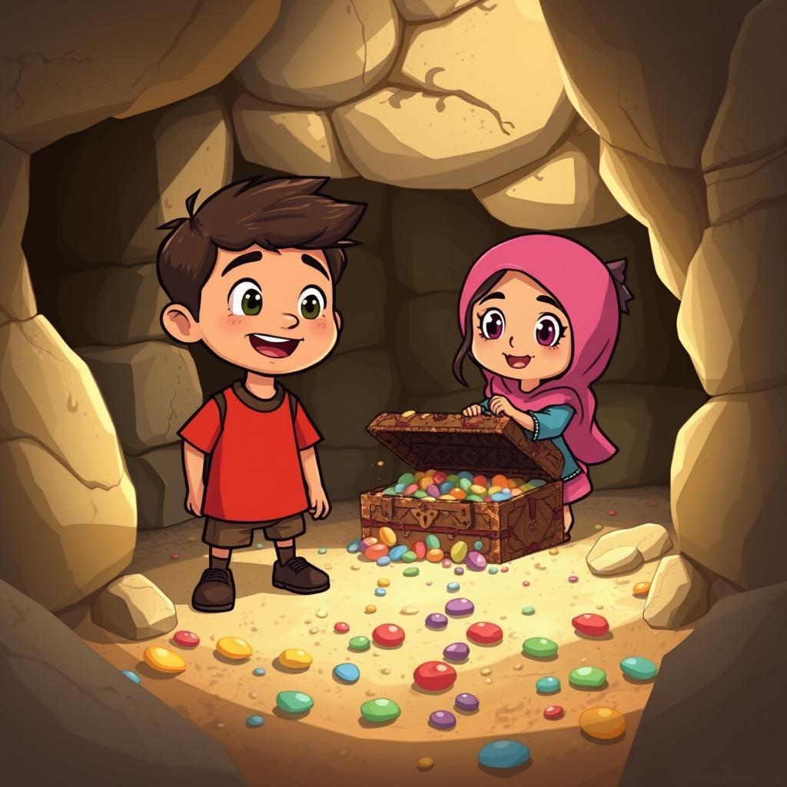

Ramy, a little boy with bright eyes and a smile that could light up the whole world, loved to explore. One sunny afternoon, he dragged his little sister, Lamia, with him to the ancient ruins behind their house. The ruins were like a giant, dusty playground, with crumbling walls, hidden doorways, and secret tunnels. Lamia, with her pigtails bouncing, followed Ramy, her eyes wide with wonder.   
  
They climbed over broken stones and peeked into dark corners, imagining the people who had lived there long ago. "Maybe there are ghosts here!" Lamia whispered, clutching Ramy's hand. Ramy chuckled. "No, silly! Ghosts don't exist. But maybe there are treasures hidden in these walls!" He pointed to a small opening in the wall. "Let's explore!"   
  
The opening led to a narrow passage, dusty and dark. Ramy held Lamia's hand tight as they squeezed through, their hearts pounding with excitement. The passage opened into a small, hidden chamber. Sunlight streamed through a crack in the ceiling, illuminating a pile of old pottery and a broken, wooden chest. "Look!" Lamia shouted, pointing at the chest. "Maybe this is where the treasure is!"  
  
Ramy gently lifted the lid of the chest, revealing not shiny gold but a collection of colorful pebbles, smooth and worn with age. He picked one up, a deep green stone that sparkled in the light. "These are beautiful," he said, handing the stone to Lamia. They spent the rest of the afternoon playing with the pebbles, their laughter echoing through the silent ruins. The stones, though not gold, were a treasure to Ramy and Lamia. They were a reminder of their adventure, a secret they shared in the heart of the ancient ruins.

# 18

# The Butterfly Meadow

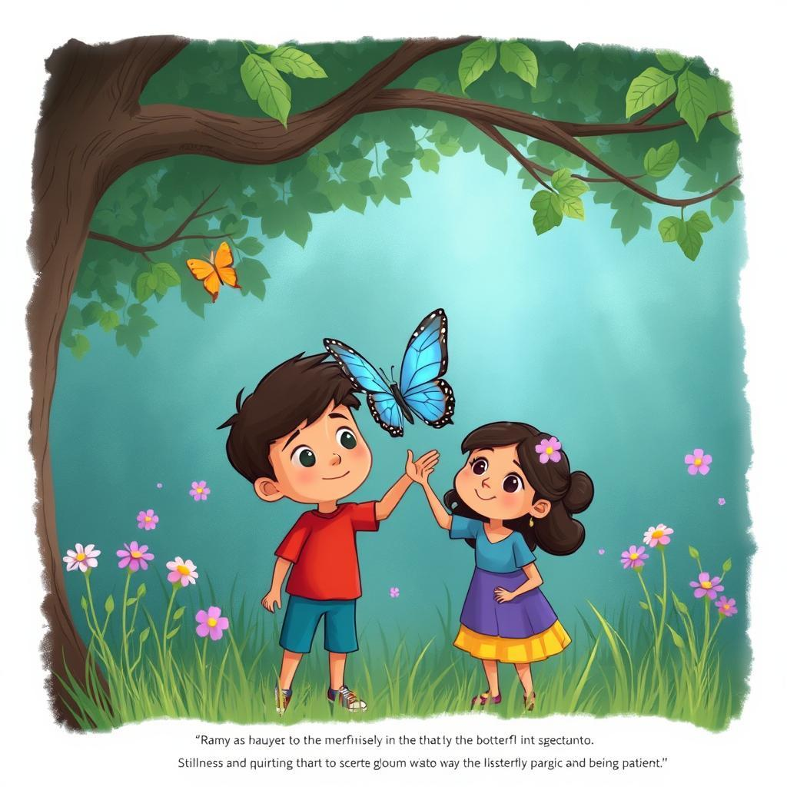

Ramy and Lamia loved to play in the Butterfly Meadow. It was a secret place, hidden behind a big, old oak tree. Sunbeams danced through the leaves, making the grass sparkle. Butterflies with wings like stained glass fluttered around, their colors so bright they seemed to glow. Ramy would chase them, laughing, his little sister Lamia giggling behind him.   
  
Today, Ramy decided to build a fort. He gathered twigs and leaves, making a tall, pointy structure. Lamia helped by bringing him pretty pebbles to decorate it. She was so proud of their fort, and she wanted to show it to the butterflies. She waved her arms, calling, "Come, butterflies, come see our fort!" But the butterflies flew away, scared by her loud voice.   
  
Ramy saw Lamia's sad face and knew what to do. He took her hand and whispered, "Let's be quiet. Butterflies like to rest on flowers. We can watch them from here." They sat down, very still, watching the butterflies dance on the flowers. They were so beautiful, with wings of orange, blue, and yellow. Lamia clapped softly, making a tiny, gentle sound.   
  
Soon, a butterfly landed on Lamia's hand. It was a big one, with bright blue wings. Lamia gasped, her eyes wide with wonder. Ramy smiled. He knew that the secret to seeing the butterflies was to be quiet and still, like a friend. The Butterfly Meadow was full of magic, and all they had to do was listen to it.

# 19

# The Northern Lights

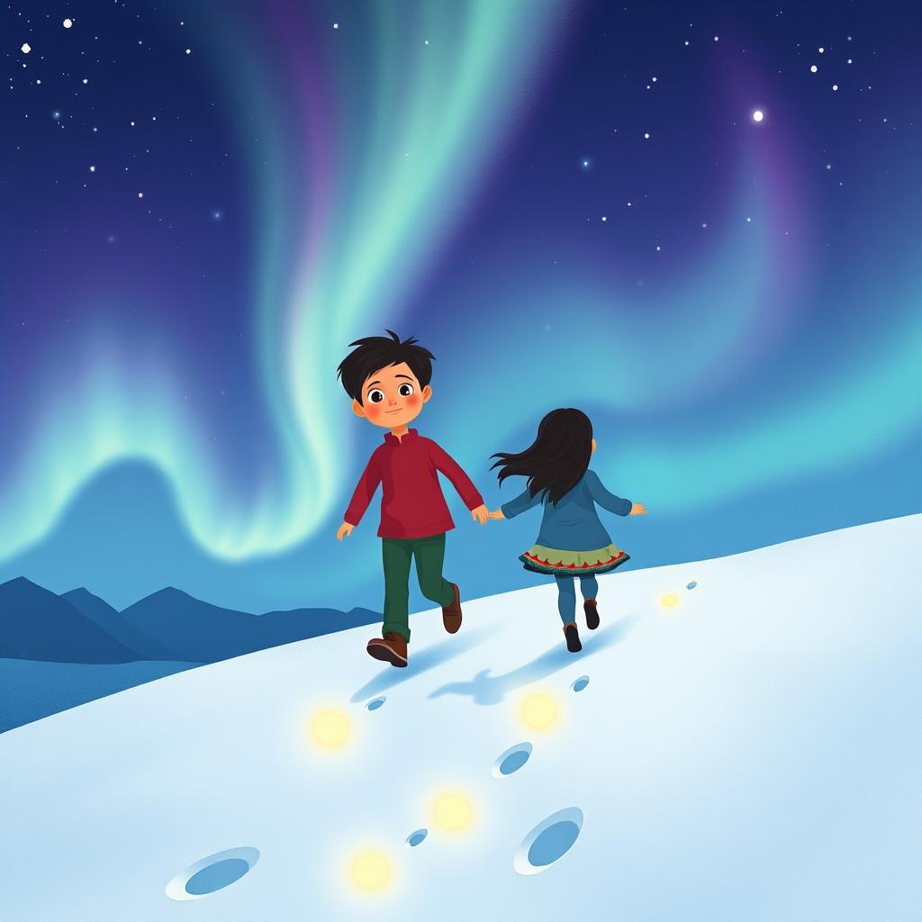

Ramy and Lamia lived in a land where the nights were long and cold. But the cold nights were also filled with magic. Every so often, the sky would burst into a riot of colors, like someone had spilled a rainbow over the black canvas of the night. This was the Northern Lights, a magical dance of light that made the children's hearts skip a beat.   
  
One night, as the Northern Lights shimmered and swirled above them, Ramy and Lamia bundled up in their warmest clothes and ran outside. They giggled and spun, their laughter echoing in the crisp air. Ramy, the older brother, knew all about the Northern Lights. He told Lamia stories of how the lights were spirits dancing in the sky, their laughter echoing in the wind. Lamia, with her big, curious eyes, believed every word.  
  
As they watched, the Northern Lights started to change. They stretched and shimmered, forming shapes like dancing animals and shimmering stars. Ramy and Lamia ran through the snow, their footprints glowing green and purple in the magical light. They chased the dancing lights, giggling and shrieking with delight. They imagined themselves flying alongside the lights, soaring through the dark sky with the spirits of the north.  
  
The night was filled with wonder. The Northern Lights danced and twirled, their colors changing with every blink. Ramy and Lamia, lost in their magical world, felt small and insignificant, yet powerful and connected to the universe. They knew that this magical night would stay with them forever, a secret memory of a magical world hidden beneath the cold, dark sky.